Chapter 13, Solution 12.

Let 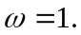 j8
j4

+ j12 j16 j20
1V
- I₁ I₂

Applying KVL to the loops,

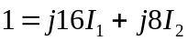 (1)
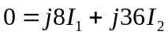 (2)

Solving (1) and (2) gives I₁ = –j0.0703. Thus

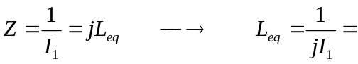 14.225 H.

We can also use the equivalent T-section for the transform to find the equivalent inductance.

